to find out the back ordered qty

------------------------------------

select ool.ordered_quantity quantity,ooh.order_number

from oe_order_headers_all ooh

,oe_order_lines_all ool

,wsh_delivery_details wdd

where ooh.header_id = ool.header_id

and ooh.header_id = wdd.source_header_id

and ool.line_id = wdd.source_line_id

AND wdd.released_status = 'B' -- Backorder

and ooh.org_id=204

Invoice

-------

run the workflow back ground process to create the automatic AR invoice.

it will launch auto invoice master program and auto invoice import program to create invoices actually.

navigation

--------------

order management super user vision operations-->view-->request-->submit a new request

choose workflow back ground process

parameters

-----------

item type : om order line

process deferred : yes

process timeout : yes

process stuck : yes

click ok

it will launch the following concurrent pogram.

auto invoice master program,Auto invoice import program

after completion of all the programs ,we will switch over to account receivables responsibility

transactions-->transactions

f11-->enter the order number under reference field.

it will give us invoice number.

here invoice number means transaction number only.

base tables

------------

ra_customer_trx_all

ra_customer_trx_lines_all

ar_payment_schedules_all

SELECT interface_header_attribute1, interface_header_attribute2,

interface_header_attribute3, interface_header_attribute10

FROM ra_customer_trx_all

WHERE trx_number = '10047320'

interface_header_attribute1*-- sales order number*

interface_header_attribute2- sales order type

interface_header_attribute3- delivery id

interface_header_attribute10-- ware house

select * from ra_customer_Trx_lines_all

where customer_trx_id='1207195' and line_type='LINE'

select due_date,amount_due_original,amount_due_remaining from ar_payment_schedules_all where customer_trx_id='1207195'

link between om and AR

---------------------------------------------------------

**header level join**

SELECT ooh.order_number, rcta.trx_number

FROM ra_customer_trx_all rcta, oe_order_headers_all ooh

WHERE trx_number = '10047320'

AND TO_CHAR (ooh.order_number) = rcta.interface_header_attribute1

**Line level join**

SELECT ooh.order_number,rcta.sales_order

FROM ra_customer_trx_lines_all rcta, oe_order_headers_all ooh

WHERE customer_trx_id='1207195'

AND TO_CHAR (ooh.order_number) = rcta.sales_order

**Line to line**

SELECT rctla.sales_order

FROM oe_order_lines_all oola, ra_customer_trx_lines_all rctla

WHERE TO_CHAR (oola.line_id) = rctla.interface_line_attribute6

AND customer_trx_id = '1207195'

query to dispay incomplete invoices or AR Open Invoices

SELECT

hca.account_number acct_nbr

, ctx.trx_number trx_nbr

, TO_CHAR(ctx.trx_date,'DD-MM-YYYY') trx_date

, ctt.NAME tran_type

, ctx.customer_trx_id

, ctx.bill_to_customer_id

, ctx.cust_trx_type_id

FROM apps.ra_cust_trx_types_all ctt

, apps.hz_cust_accounts hca

, apps.ra_customer_trx_all ctx

WHERE NVL(ctx.complete_flag,'N')='N'

AND ctx.bill_to_customer_id = hca.cust_account_id

AND ctx.cust_trx_type_id = ctt.cust_trx_type_id

**or in simple sentence like below**

SELECT * FROM Ra_customer_trx_all where complete_flag='Y' and org_id=204

**How to display “bill to” customer name and bill to customer number**

select hp.party_name,

hca.account_number

from ra_customer_trx_all rcta,hz_parties hp,hz_cust_accounts hca

where hp.party_id=hca.party_id

and hca.cust_account_id=rcta.bill_to_customer_id

and rcta.TRX_NUMBER='10047320'

**How to display “ship to” customer name and bill to customer number**

select hp.party_name,

hca.account_number

from ra_customer_trx_all rcta,hz_parties hp,hz_cust_accounts hca

where hp.party_id=hca.party_id

and hca.cust_account_id=rcta.ship_to_customer_id

and rcta.TRX_NUMBER='10047320'

**credit memo – negative amount**

**how to derive credit memo ?**

select rcta.TRX_NUMBER invoice_number, credit.TRX_NUMBER credit_number from

ra_customer_trx_all rcta,ra_customer_trx_all credit

where rcta.CUSTOMER_TRX_ID=credit.PREVIOUS_CUSTOMER_TRX_ID

and rcta.TRX_NUMBER='10047320'

*-- self join*

**credit memo**

Credit Memo: Negative amount to decrease the balance of the invoice.  
Example of scenario in which a Credit Memo is created:  
Say you have created an invoice of $5000 for a customer ABC and have sent it across. Later upon receiving the goods, customer realized one of them worth $1000 is defective and had to return it. We have already issued an invoice of $5000 but now we are supposed to charge them only $4000 because of the refund of $1000 for the defective piece. In such a situation, we create a credit memo of $1000 and apply to the invoice of $5000 to bring down its balance to $4000. We again send the credit Memo note to the customer to let them know that they have to pay us only $4000.

**To create credit memo ,go to actions- credit memo**

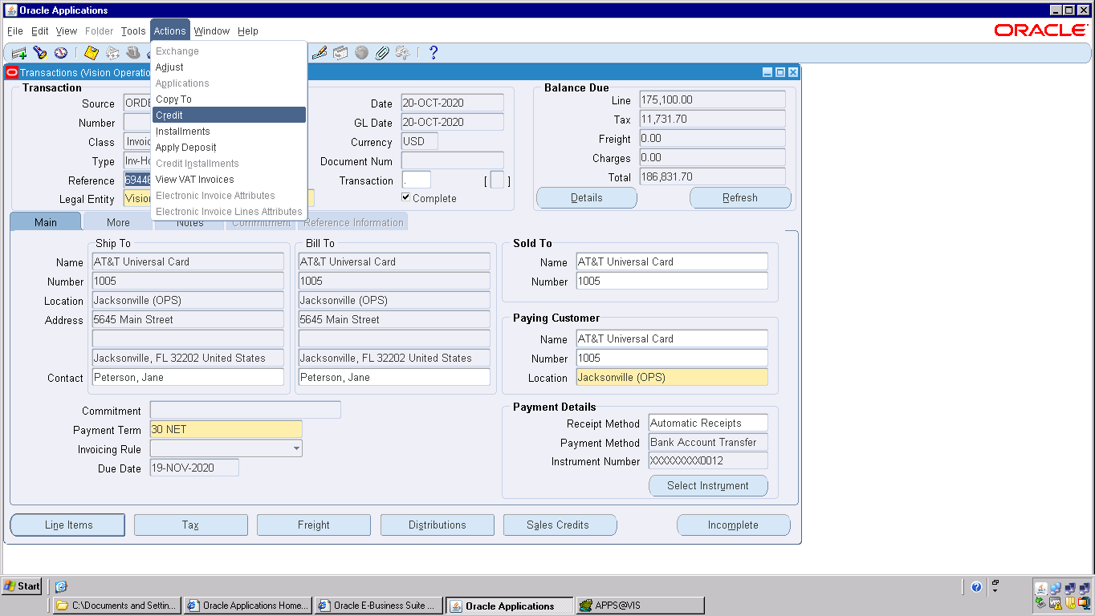

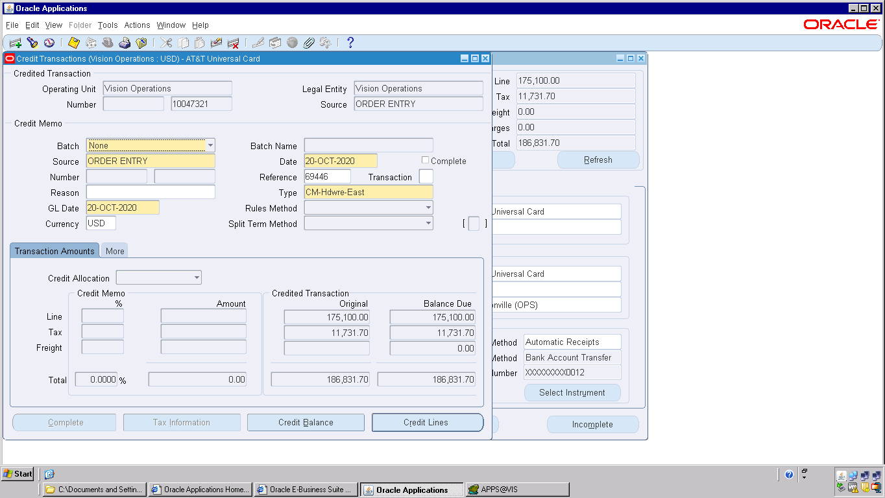

click on credit lines

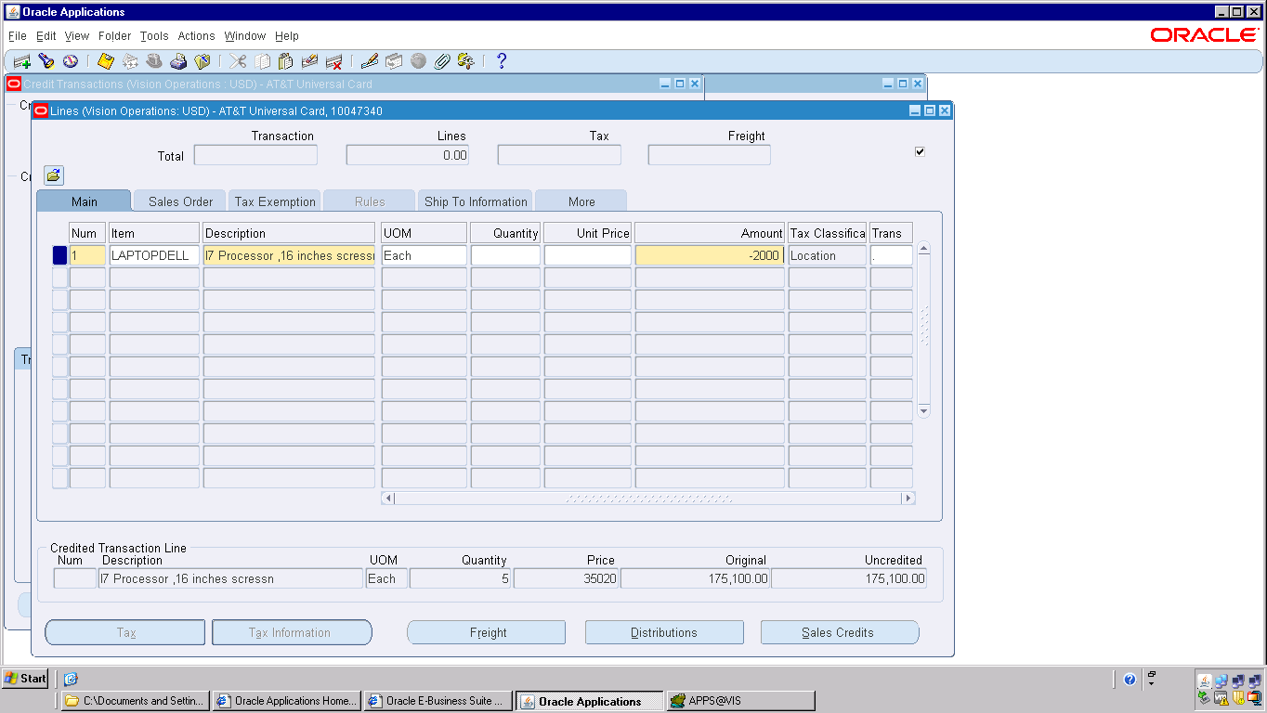

enter negetive amount -2000,it will become <2,000.00>

click on save it will generate credit memo number

